 **trainee*bee***





TraineeBee is a project made possible by mboRijnland from Leiden and City College Plymouth in Plymouth.

Supervised by: Rob Chadwick, Cat Shepard, Samantha Harvey, Tom Bergier, Stef Smits, Dennis Boot, Willem Brock.

Made by: Josh Dorrington, Josh Rounce, Abbey Wooldridge, Tom Richardson, Racheal Taverner, Nathan Ford, Eefje Karremans, Niels Mooren, Jorden van Vegten, Parsa Gholamhossein, Kador Özsoy, Dave Scheurwater, Liam Meijles.

Index

General information 3

Colleges 3

Companies 3

Students 3

Internship offers 3

Students not searchable 3

User stories 4

Homepage: 4

About us page: 4

Contact page: 4

Information page for companies: 4

Information page for colleges: 4

Proof of concepts 5

Wireframes 6

Mockups 7

**THIS IS ALL SUBJECT TO CHANGE!!!**

# General information

There are three different kind of users:

* Companies
* Students looking for internships
* colleges

## Colleges

Colleges can contact us to be added to our database of companies.

When we accept their request they get email with login information for the teachers that are for instance involved with the internship (internship coaches).

Internship coaches are allowed to make student accounts.

They should overlook the students and see if they make the right choices for internships.

## Companies

Companies can contact us to be added to our database as company. When they are accepted we will send them a confirmation email with their login information. When they login they can change their company information regarding small info text, amount of employees(small, medium or large sized), contact information, used programming languages, preferred skills (from skill list), industry sector and company logo.

## Students

Student accounts are being created by their internship coaches. A student can give up skills that the student masters so our search function can find the perfect company. It is also possible to say in what industry you want your internship to be in.

## Internship offers

The idea is that companies can open “job” offers for internship like on job sites. In those job offers they can fill in what kind of preferred skill they want you to have (for instance what kind of languages they want you to fluent in).

## Students not searchable

For companies it is not possible to search for students due to laws that we don’t want to deal with.

Also because we don’t know if all the companies are going to do good things with the information (Data leaks are really expensive).

# User stories

## Homepage:

If you are logged in the homepages shows a list with internship offers.

If you are not logged in the homepages shows a welcome page with a login form.

## About us page:

This page shows information why we started this website and what the point is of this website. Doesn’t matter if logged or not.

## Contact page:

Contact information about our “company”.

## Information page for companies:

Text why they should join our website for students looking for internships.

## Information page for colleges:

Text why they should join our website to help students find internships.

Maybe even why they should integrate internships in their courses.

## Company profile page:

You need to be logged in to see a company profile page.

It will show some basic information about the company.

# Proof of concepts

**[PROOF OF CONCEPT]** Internship orientation:

If you can not decide what internship you want to do or at what company you can try our internship helper.

Questionnaire of around 20-25 questions about your perfect internship.

Result will try to show an internship offer that you like.

**[PROOF OF CONCEPT]** Writing reviews for companies:

Able to write reviews for companies regarding your experience at that company.

Maybe even able to give them a rating from 1-10 or 1-5.

# Wireframes

## User profile

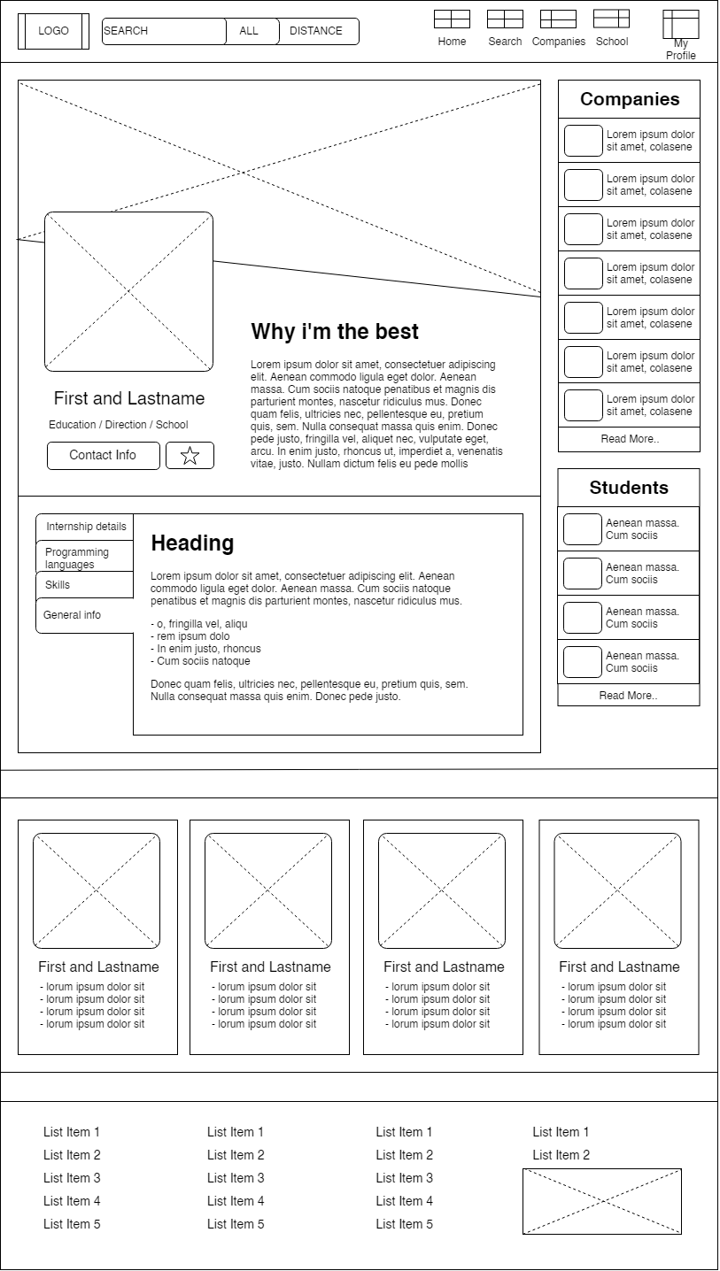

## Company Profile

# Mockups

